

Subscribe to DeepL Pro to edit this document.  
Visit www.DeepL.com/Pro for more information.

**Category B PlusEnergieBauten**PlusEnergieBau® Solar Prize

**TheRomanCatholic Church of St. Franziskus Ebmatingen ,built 1989,isemission-free after the 2018/19 energy-saving renovation. Thanks to considerably improved roof insulation, the solar-powered geothermal heat pump , solar heat utilisationwith 161 m2 of photovoltaic-thermal modules (PVT) and LED lighting, the previous total energy requirement of 84,400 kWh/a hasbeen reduced by around 35% to 54,700 kWh/a. The old oil heatingsystemwas torn out. This saved 7,000 litres of heating oil per yearand avoided 21 t CO2 emissions per year . The exemplary 90 kW PV system,integratedover the entire surface andoriented north-south ,generates 78,900 kWh/a. With this, the church hasanenergy supply of**

**221% .**

**221% PEB churchrenovation, 8123 Ebmatingen/ZH**

The Roman Catholic Church of St. Francis Ebmatingen , built in 1989, urgently neededtoberenovated . An old oil-fired heatingsystem, an outdated insulation system and a leaking roof in placesresulted in a disproportionately high energy requirementof 84,400 kWh/a. In the winter of 2018/19 ,the building and energy renovation followed with new insulation, a geothermal probe heat pump, photovoltaic with thermal energy(PVT) and LED lighting. As a result of these measures ,the previous total energy requirement of 84,400 kWh/a fell by

35% to 54,700 kWh/a. The character of the

The PlusEnergy Church was nevertheless preserved.

The refurbishment costs amount to CHF 1.2 million. Of the total of 543 m2 of the PV system, whichis optimally integratedinto the roof , 161 m2 areequippedwith PVT modules .In addition to electricity ,theyalso produce 41,800 kWh/a of heat, which in summerisfed 300 m deep into the ground . In winter , part of itis recovered again.

The installed capacity of the PV/PVT system is 90 kW. This means that annually

78,900 kWh/a CO2-free electricity and 41,800 kWh/a thermal energy generated by the 161 m2 ofthermal solar collectors .

Both plants generatea total of 120,700 kWh/a. This means that the PEB churchhasan energy supply of 221% .

Therenovation of the church servesas a model both intermsof energy and ecology . The PEB church of St. Franziskus Ebmatingen willreceivethePlusEnergieBau Solar Prize 2019for this .

The CatholicChurch of St. Francis in Ebmatingen (ZH),built in 1989, was indire needof renovation. With an old oil heating system , inadequate insulationand a roof that leaked in places, it required adisproportionately high energy demand of 84,400 kWh/a. Inthe winter of 2018/19, thestructural and energy renovation included new insulation, a geothermal heat pump , aphotovoltaic and thermal (PV-T) infrastructure and LED lighting. These measures reduced consumptionby 35% , from 84,400 to 54,700 kWh/a.

Theoriginal appearanceof theBEPchurchhas been preservedandthe renovation cost 1.2 million francs. Of the 543 m2 ofthe roof-integrated PV system,161 m2 are equippedwithPV-T modules. They produce electricity but also 41'800 kWh/aof additional heat . Theheat isinjected into the ground ata depth of 300 m inthe summerand recovered inthe winter bymeans of a heat pump .

Withan outputof 90 kWp, thePV-Tsub-structure generates 78,900 kWh/a CO2-free . The BEPchurch supplies a total of

120'700 kWh/a andthus ensures a self-provisioning

duction de 221%.

Theentire renovation is a great success story from energy and ecological point of view . The CatholicChurch of St.Francis Ebmatingen awarded the BEP 2019Solar Prize for this .

**Technical data**

**Thermal Insulation**

wall: 9 cm U-value: 0.21 W/m2K

|  |  |  |  |  |
| --- | --- | --- | --- | --- |
| Roof:  floor: windows: | 24 cm  8 cm triple | U-value:  U-value: U-value: | 0.16 W/m2K  0.19 W/m2K  0.70 W/m2K | |
| **Energy demand before renovation [100%[ 154%].** | | | | |
| EBF: 1'070 m2 |  | kWh/m2a | % | kWh/a |
| Hot water: |  | 4.3 | 6 | 4’601 |
| heating: |  | 68 | 86 | 72’760 |
| Electricity: |  | 6.6 | 8 | 7’062 |
| **Total EB:** |  | **78.9** | 100 | **84’423** |

**Energy demand after [65%| 100%]**

EBF: 1'070 m2 kWh/m2a % kWh/a

Hot water: 1.0 2 1’075

Solar : 39.0 77 41’766

Electricity WP: 6.4 12 6’813

Electricity: 4.7 9 5’029

**Total EB: 51.1**  **54’683**

**Energy supply**

Own-EV: m2 kWp kWh/m2a % kWh/a

PV: 543 89.9 145.2 144.2 78’881

|  |  |  |
| --- | --- | --- |
| SK roof: 161 259.5  **Own energy supply** | 76.4  **221** | 41’776  **120’657** |
| **Energy balance (final energy)** | % | kWh/a |
| **Own energy supply** | **221** | **120’657** |
| total energy demand: | 100 | 57’683 |
| Solar power surplus: | 120 | **62’974** |

**Confirmed by the cantonal electricity companies**

**Zurich (EKZ)** on 08.07.2019

Daniel Meier, phone +41 58 359 57 40

**Personsinvolved**

**Location of the building**

Roman CatholicChurch St. Francis

Parish vicariate Maur

Bachtelstrasse 13, 8123 Ebmatingen/ZH Tel. 044 980 19 90, [pastoral. eb@zh.kath.ch](mailto:pastoral.eb@zh.kath.ch)

**Client**

Roman Catholic parish Egg/ZH President of , Louis Landolt Flurstrasse 10, 8132 Egg/ZH

**Architect**

Studer Architect

D. Studer, dipl. Arch. ETH SIA Hüttenmattweg 19, 5213 Villnachern

41 79 324 17 00, [d.studer@studerarchitekt.ch](mailto:d.studer@studerarchitekt.ch)

**HLS planner**

W+P AG, Marlon Keller

Zweierstr. 129, 8003 Zurich

41 44 454 10 64, [m.keller@wpe.ch](mailto:m.keller@wpe.ch)

**PVT planner**

BS2 AG, Dr. Niklaus Haller, Brandstr. 33, 8952 Schlie- ren, Tel. +41 44 275 25 09, [haller@bs2.ch](mailto:haller@bs2.ch)

**Realisation of PV systems**

winsun AG, Benjamin Wenger, Rheinweg 1, 8200

Schaffhausen, Tel. +41 52 212 27 00, [info@winsun.ch](mailto:info@winsun.ch)

42| SwissSolar Prize 2019| Prix Solaire Suisse 2019

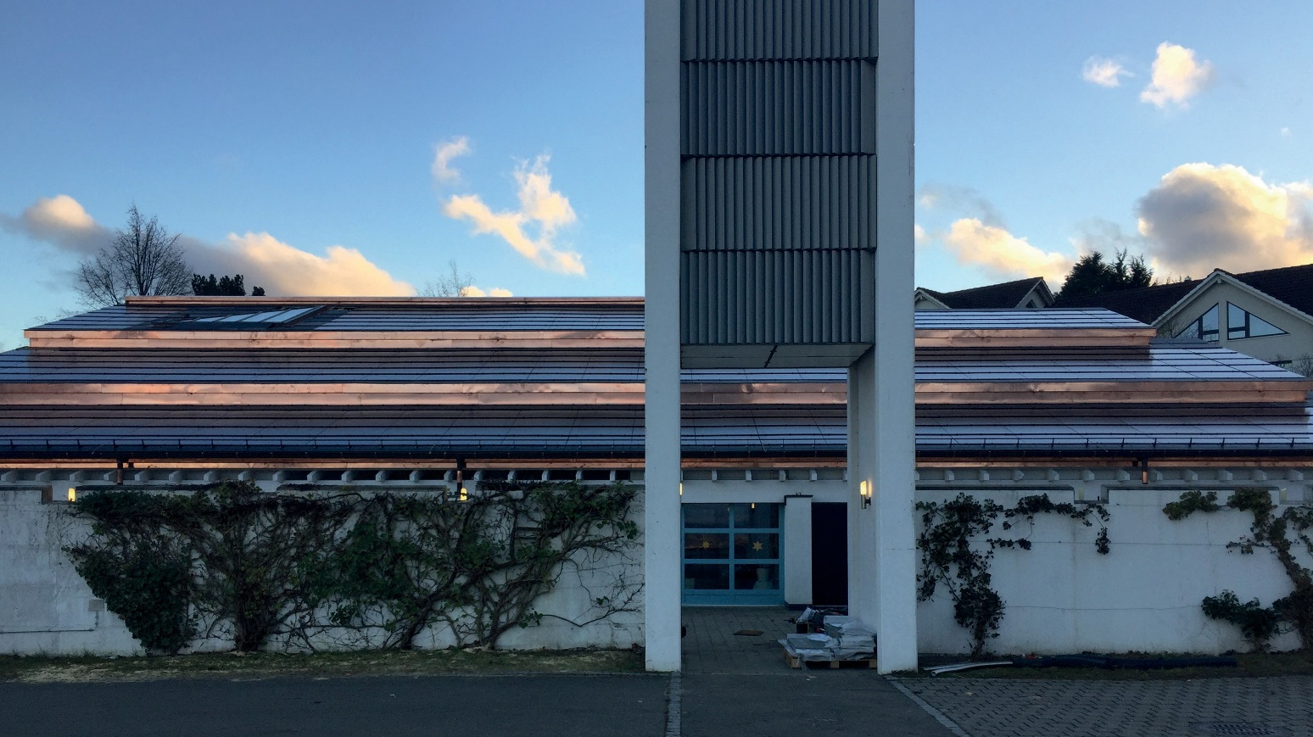

**1**

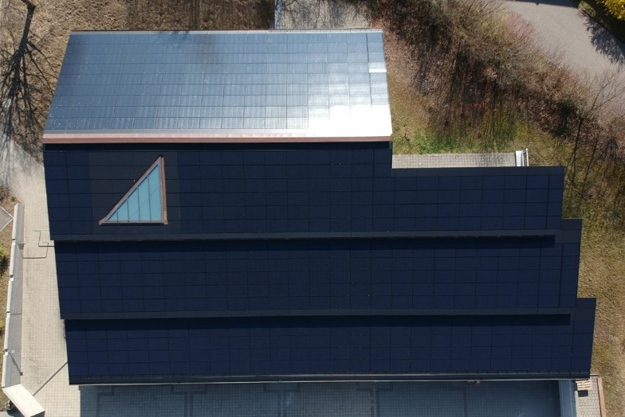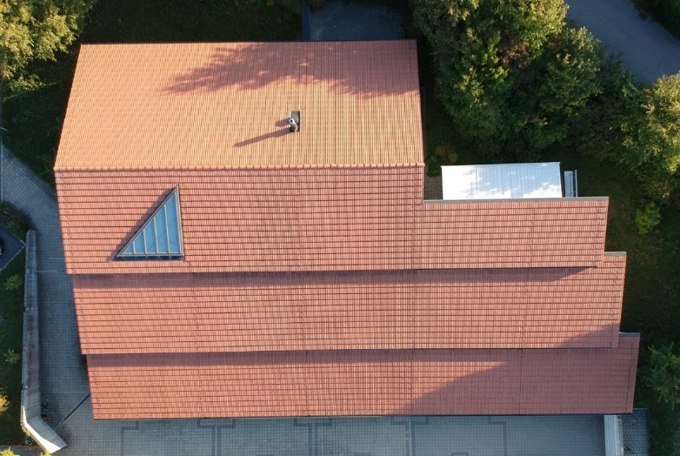

**2 3**

**1 The optimally integrated PV roof systemof thePlusEnergie-Kirche generates78,881 kWh ofCO2-free solar power annually .**

**2 Before the refurbishment ,theenergy requirement was**

**84'400 kWh/a.**

**3 The fully integrated PVT roof systemproduces 41,800 kWh/a of thermal energy inaddition to electricity .**

Swiss Solar Prize 2019| Prix Solaire Suisse 2019| 43